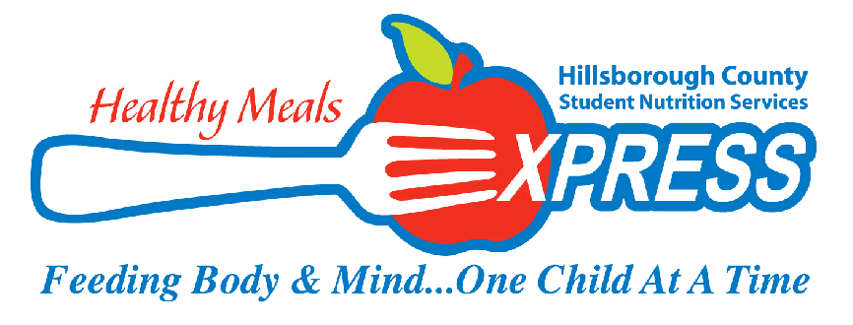
FEBRUARY 2021 MENU
1  BREAKFAST  Assorted Cereal with Goldfish Graham  Apple Crisp Bites  Low Fat Milk  LUNCH  Sloppy Joe Sandwich  Sweet Kernel Corn  Peach Fruit Cup  Assorted Low Fat Milk | 2  BREAKFAST  Eggo Mini Waffles With Syrup  or  Apple Cinnamon Craisin Bar  100% Juice  Assorted Low Fat Milk  LUNCH  Cuban Sandwich  Apple Sauce  Tropical Juice Box  Assorted Low Fat Milk | 3  BREAKFAST  Assorted Cereal with Goldfish Graham  100% Juice  Assorted Low Fat Milk  LUNCH  Popcorn Chicken Chunks  Baby Carrots w/Lite Ranch Dip  Peach Cup  Donut Holes  Assorted Low Fat Milk | 4  BREAKFAST  Banana Chocolate Chunk  Protein Bar  100% Juice  Assorted Low Fat Milk  LUNCH  Turkey and Swiss Croissant  Cucumber Slices w/Lite Ranch Dip  100% Fruit Juice  Assorted Low Fat Milk | 5  BREAKFAST  Danimals Yogurt  w/Cinnamon Goldfish Graham  100% Juice  Assorted Low Fat Milk  LUNCH  Macaroni and Cheese  Cauliflower w/Lite Ranch Dip  Fresh Apple Slices  Assorted Low Fat Milk
8 BREAKFAST  Eggo Mini Waffles w/syrup  100% Juice  Assorted Low Fat Milk  LUNCH  Rotini with Meat Sauce  Honey Glazed Carrots  Peach Fruit Cup  Assorted Low Fat Milk | 9  BREAKFAST  Assorted Cereal w/ Cinnamon Goldfish Graham Cracker  100% Juice  Assorted Low Fat Milk  LUNCH  Italian Deli Sub  Sliced Cucumbers w/Lite Ranch Dip  100% Fruit Juice  Assorted Low Fat Milk | 10  BREAKFAST  Mini Blueberry Pancakes  w/Syrup  100% Juice  Assorted Low Fat Milk  LUNCH  Southern Style Chicken Bites  BBQ Baked Beans  Applesauce  Cheez-It Crackers  Assorted Low Fat Milk | 11  BREAKFAST  Banana Chocolate Chunk Protein Bar  100% Juice  Assorted Low Fat Milk  LUNCH  Bacon Burger Mac n Cheese  Steamed Broccoli  Raisins  Assorted Low Fat Milk | 12  Non-Student Day
15  PRESIDENT’S DAY | 16  BREAKFAST  Eggo Mini Waffles With Syrup  100% Fruit Juice  Assorted Low Fat Milk  LUNCH  Cuban Sandwich  Apple Sauce  Tropical Juice Box  Assorted Low Fat Milk | 17  BREAKFAST  Apple Cinnamon Chewy Bar  100% Juice  Assorted Low Fat Milk  LUNCH  Popcorn Chicken Chunks  Baby Carrots w/Lite Ranch Dip  Fruit Cup  Cheez It Crackers  Assorted Low Fat Milk | 18  BREAKFAST  Assorted Cereal w/Cinnamon Graham Goldfish Cracker  100% Juice  Assorted Low Fat Milk  LUNCH  Turkey and Swiss Croissant  Cucumber Slices w/Lite Ranch Dip  100% Fruit Juice  Assorted Low Fat Milk | 19  BREAKFAST  Danimals Yogurt  w/Cinnamon Goldfish Graham  100% Juice  Assorted Low Fat Milk  LUNCH  Macaroni and Cheese  Cauliflower w/Lite Ranch Dip  Fresh Apple Slices  Assorted Low Fat Milk
22  BREAKFAST  Eggo Mini Waffles w/Syrup  100% Juice  Assorted Low Fat Milk  LUNCH  Rotini with Meat Sauce  Honey Glazed Carrots  Peach Fruit Cup  Assorted Low Fat Milk | 23  BREAKFAST  Assorted Cereal w/ Cinnamon Goldfish Graham Cracker  100% Juice  Assorted Low Fat Milk  LUNCH  Italian Deli Sub  Sliced Cucumbers w/Lite Ranch Dip  100% Fruit Juice  Assorted Low Fat Milk | 24  BREAKFAST  Apple Cinnamon Chewy Bar  100% Juice  Assorted Low Fat Milk  LUNCH  Southern Style Chicken Bites  BBQ Baked Beans  Applesauce  Cheez It Crackers  Assorted Low Fat Milk | 25  BREAKFAST  Mini Blueberry Pancakes w/syrup  100% Juice  Assorted Low Fat Milk  LUNCH  Buffalo Chicken Mac n Cheese  Steamed Broccoli  Raisins  Assorted Low Fat Milk | 26  BREAKFAST  Danimals Yogurt  w/Cinnamon Goldfish Graham  100% Juice  Assorted Low Fat Milk  LUNCH  Turkey and Swiss Croissant  Fresh Apple Slices  Tropical Juice Box  Assorted Low Fat Milk

